IT 5434 Network Security Fundamentals
Lab Assignment 9 (L9)
60 points
Due: see due date under Dropbox on Folio

Student Name:
Eagle ID:
Email Security
Encrypting and Digitally Signing Emails with Thunderbird

- Imagine you are working for a company or organization. Prepare a guide for all employees below with screenshots so it will provide detailed instructions to a non-technical person for installing required software and tools as well as encrypting and signing emails at work.
- Search for useful online resources (and place them as references in your guide) about how to use the recent version(s) of Thunderbird to encrypt and sign emails. The new Thunderbird versions would NOT need to install extra software or add-ons, such as the Gpg4win or Enigmail, for this lab.
- For testing purpose, you would want to create an email account for the purpose of this lab assignment.
- Your guide will need to show the entire processes with screenshots and instructions for major steps in Thunderbird:
  - downloading and installing Thunderbird
  - email account creation/configuration
  - key generation and configurations (under “Preferences”, “Account Settings” and “End-To-End Encryption” in Thunderbird menus)
  - composing, encrypting, digitally signing, and then sending an email to yourself
  - having received the encrypted and signed email from yourself

Your guide starts below. You should prepare your guide with your own descriptions and screenshots.

- I went online and downloaded the thunderbird application from this website :https://www.thunderbird.net/enGB/.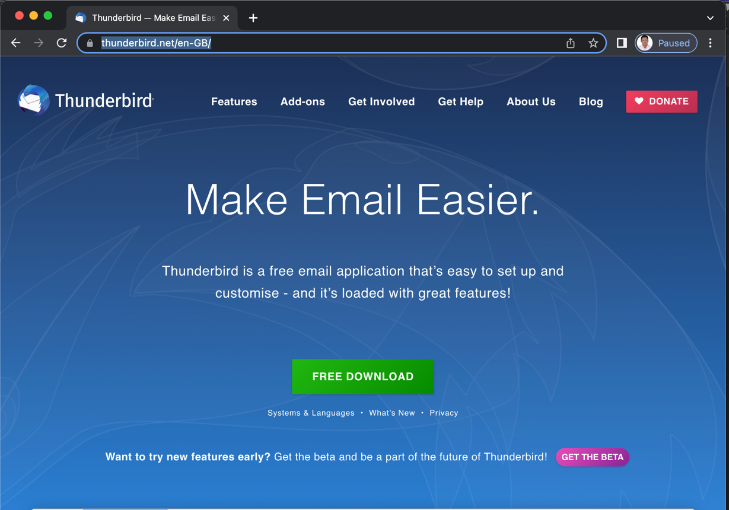
- After downloading thunderbird, I install the file on my computer. The installation process is shown below. I simply dragged the thunderbird file into the application folder, then it installed. Then I opened the launchpad and found the application icon. I clicked the application and opened the home page.

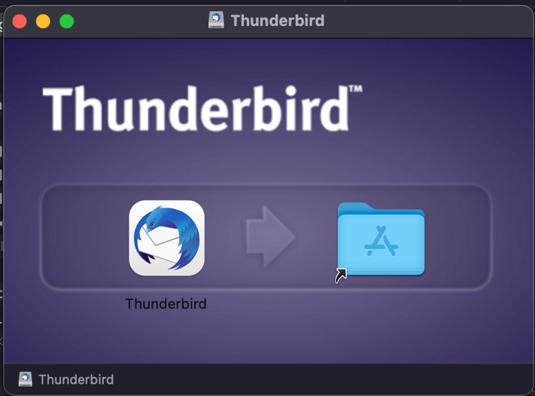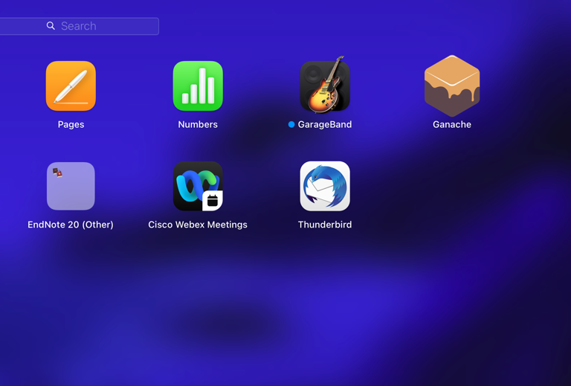
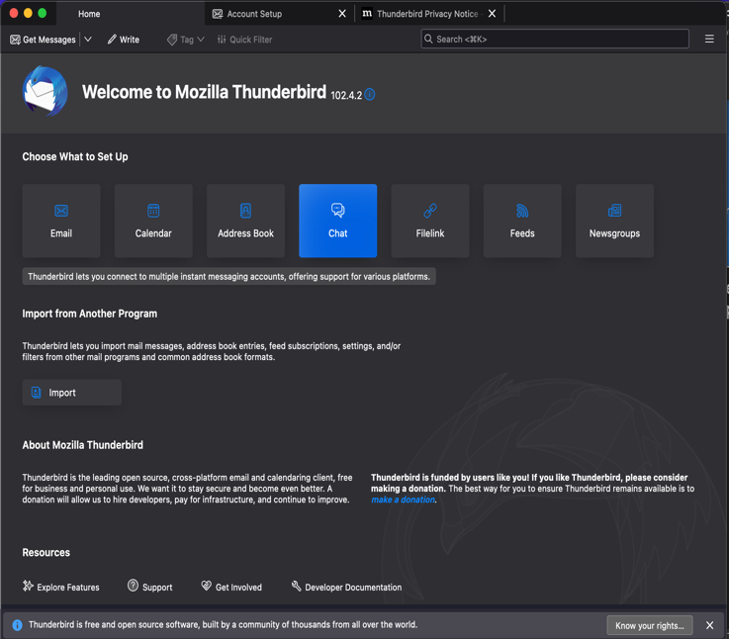
- Then I created a free email account with a service incorporated in thunderbird. The name of the free email was called eopara@mailfence.com. This email account was setup to allow access to thunderbird. Users can also use existing email address to setup an existing account on thunderbird. In the configuration setting I choose IMAP, this is because it had the necessary configuration required for this lab.
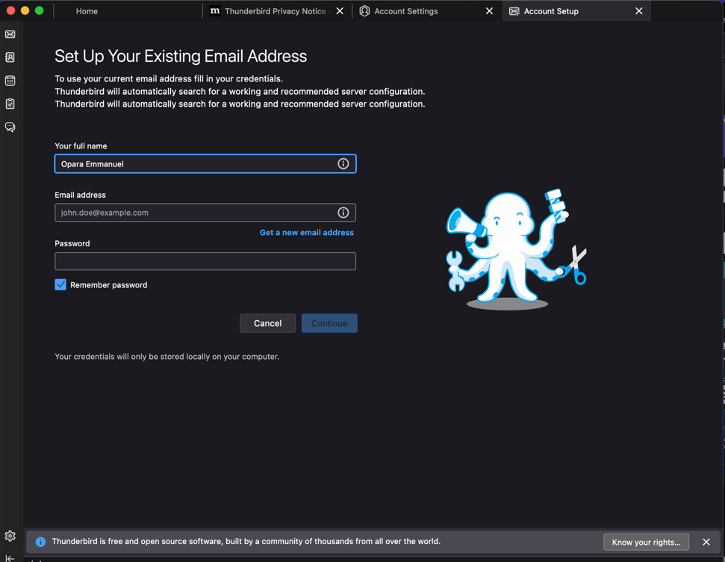
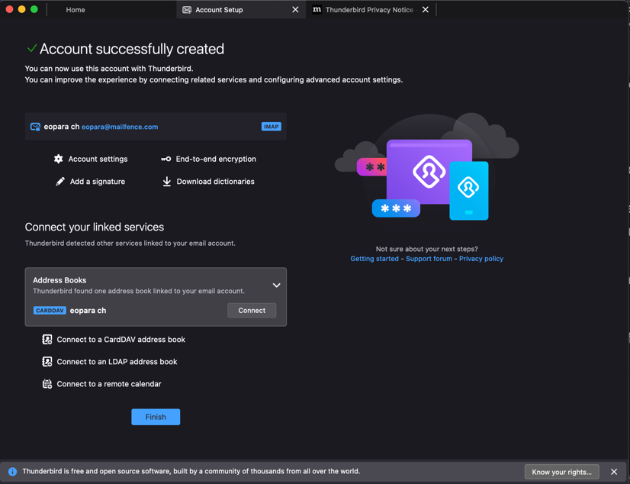
Then I connected the email created to the thunderbird application in the screenshot below. If you look closely, the “connect” button has changed to “connected”.
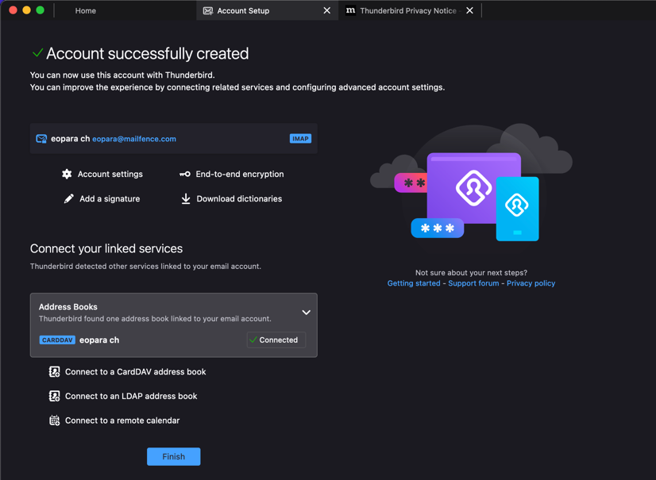
- The next step is to generate the end-to-end encryption key in the account settings. I clicked the “end-to-end encryption” button located on the page. Then I clicked on “Add key” to create a new OpenPGP key.

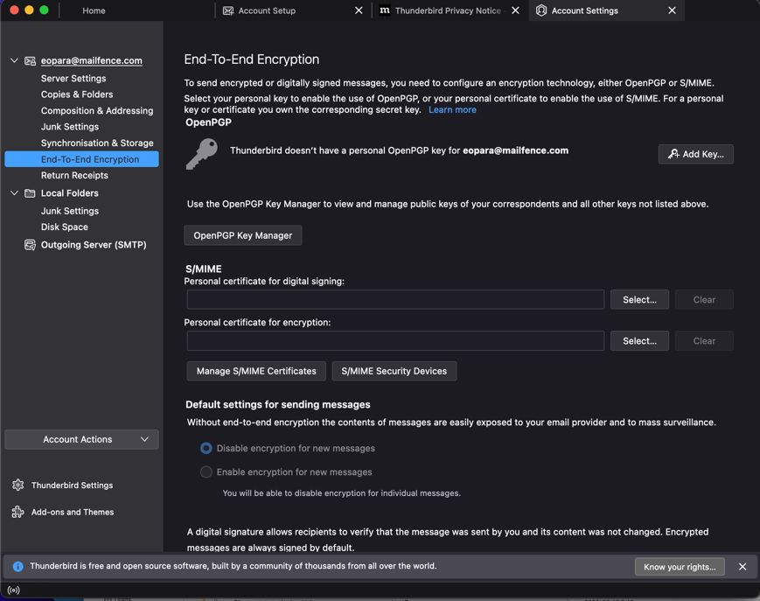

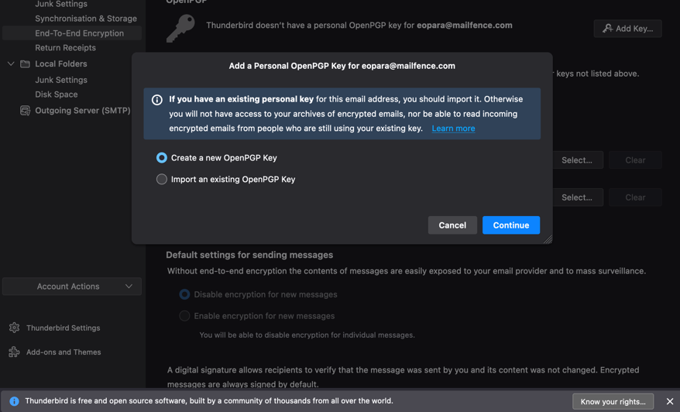

When generating the key, I selected an expiration date for the key to be “1 year”, I also selected a key type and the key size. Then it took me to a confirmation page.

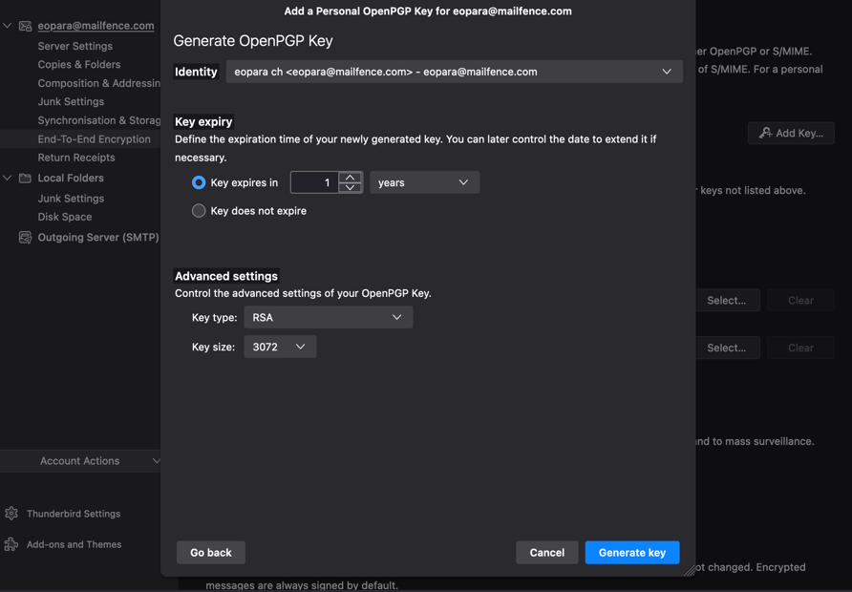
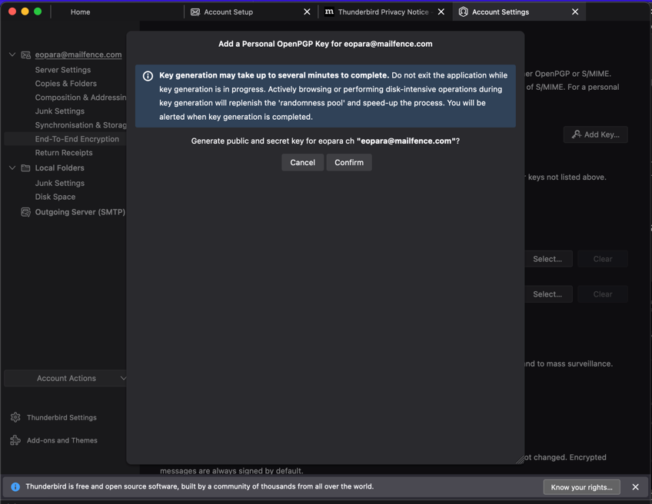
- Finally, lets test all our configuration settings by composing, encrypting and digital signing an email sent to another user. For this experiment, I sent a mail to the email I created back in the earlier steps. Go to the home page and click the “Write” button to compose a mail.
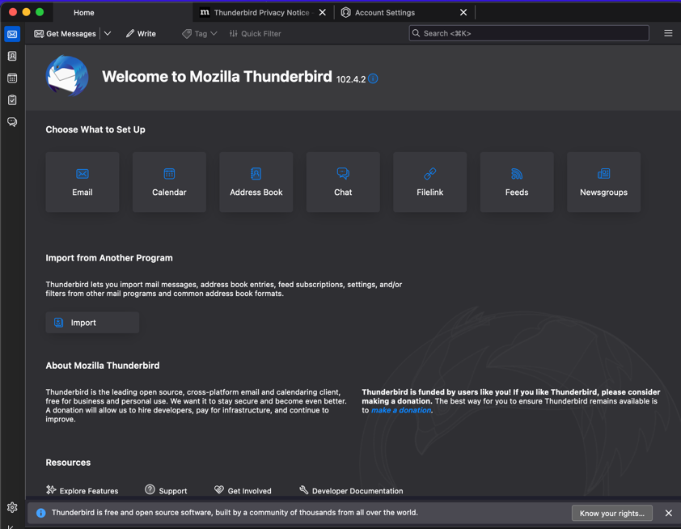
After clicking it, it should bring you to a page like the screenshot shown below. Then I composed the mail I wanted to send.

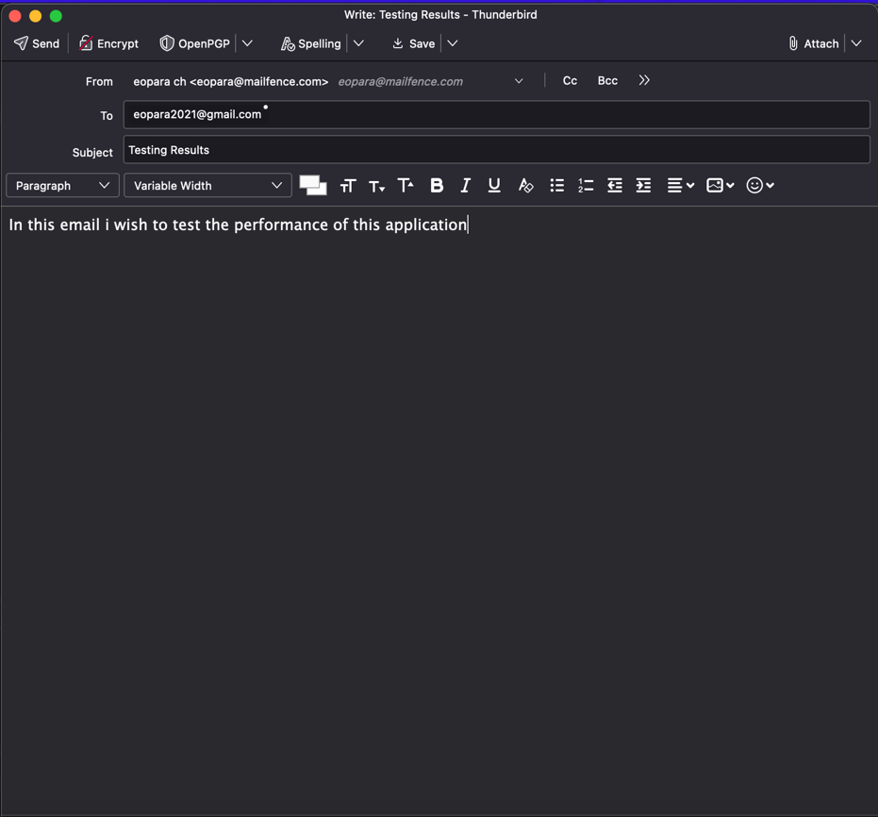
After composing the mail, I click on “OpenPGP” located at the top of the page to encrypt my message and digitally sign. After clicking both the encrypt and digital signing, you should see a checkmark beside the two buttons. Then you can send
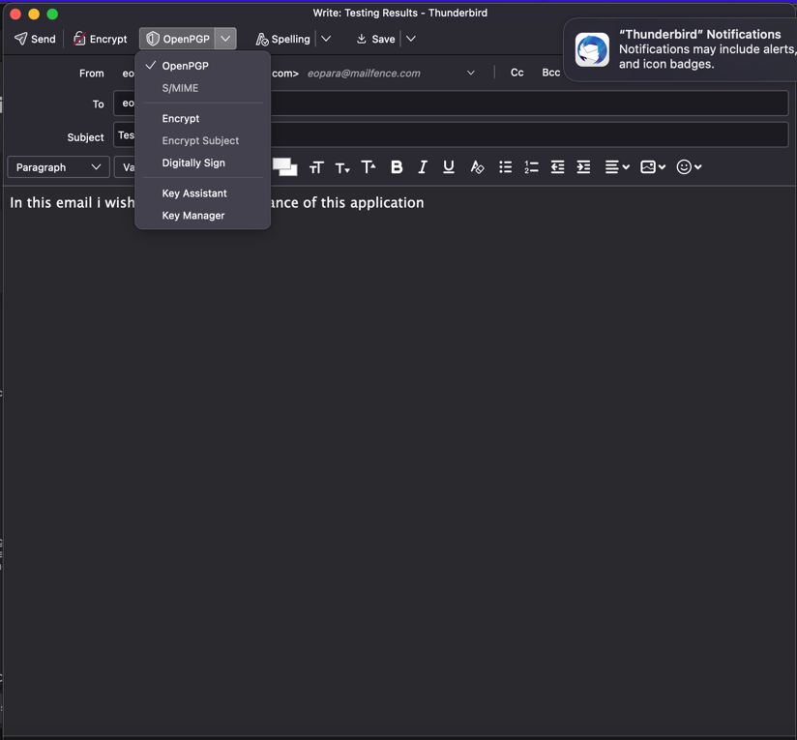
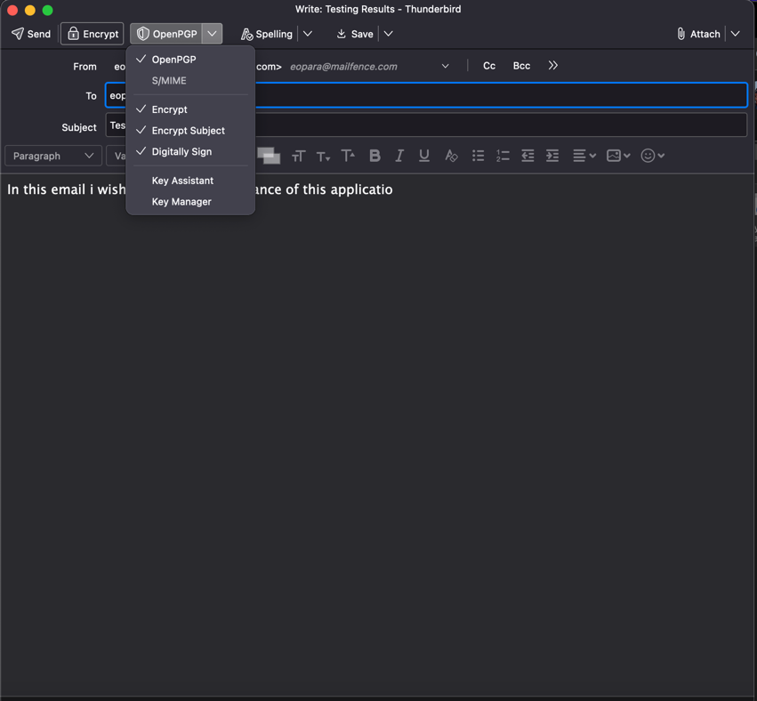

Depending on the network and computer, the sending time might take longer. After sending it, I went to my mailbox to open the mailbox to view the mail.

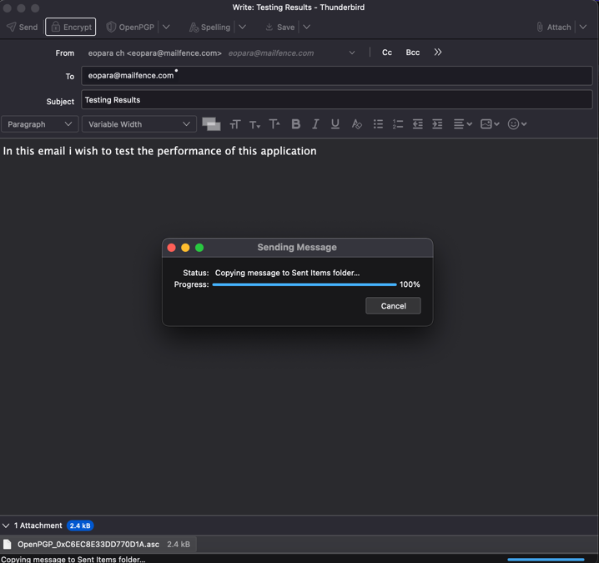

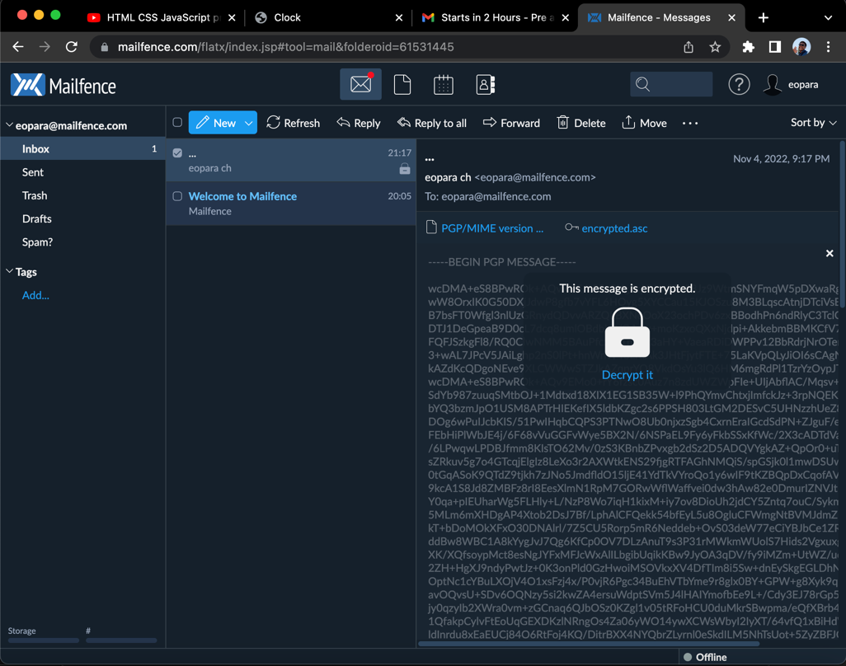

Using my personal key I was able to decrypt the message and view it.
